**Fundamentals** **of** **data literacy with tableau**

**Project title :**

**Political juggernauts** – **A quantitative analysis of candidates in the 2019 Lok sabha elections**

**Team id :**

**NM202309351**

**Team lead id :**

**D46810850476DAD97E741153D38A9851**

**Team members id :**

1. **D46810850476DAD97E741153D38A9851**
2. **A23B8C0F5AF741199974EED7695BBE6F**
3. **37BF235EDE7372D98E347C51E4E93D1B**
4. **4F3BF5AC6FADB3DBAB149C5073FC315**

**Project report**

**Introduction :**

Political Juggernauts: A Quantitative Analysis Of Candidates In The 2019 Lok Sabha Elections

The Lok Sabha is composed of representatives of people chosen by direct election on the basis of Universal Adult Suffrage. The Constitution of India allows for a maximum of 550 members in the House, with 530 members representing the States and 20 representing the Union Territories. The 17th Lok Sabha was formed by the members elected in the 2019 Indian general election. Elections, all across India, were conducted in seven phases from 11 April 2019 to 19 May 2019 by the Election Commission of India.

The Bharatiya Janata Party received 37.36% of the vote, the highest vote share by a political party since the 1989 general election, and won 303 seats, further increasing its substantial majority. In addition, the BJP-led National Democratic Alliance (NDA) won 353 seats.

**Problem defining and design thinking :**

* **Empathy map :**

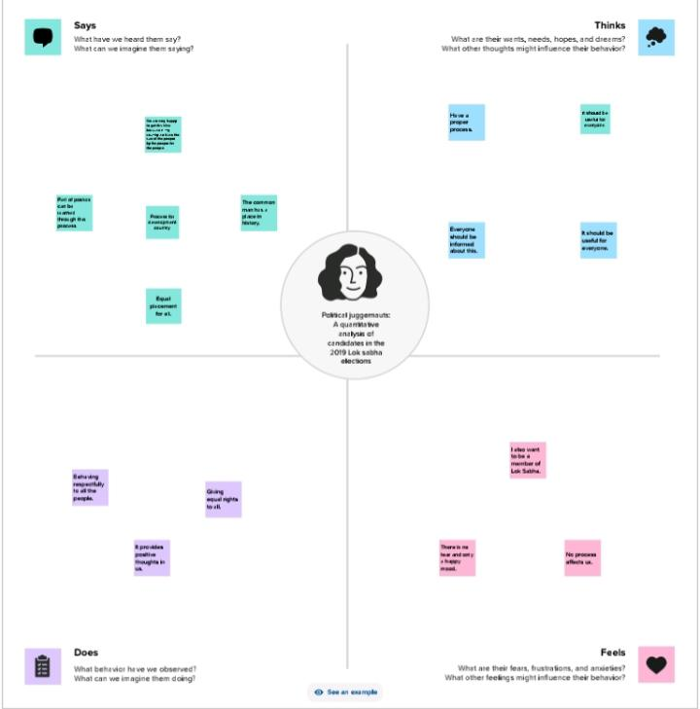

* **Brainstorming:**

**Result** :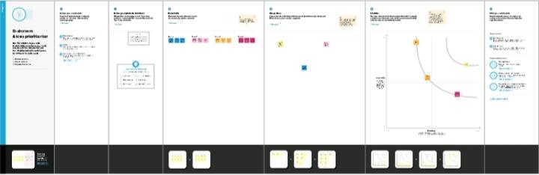 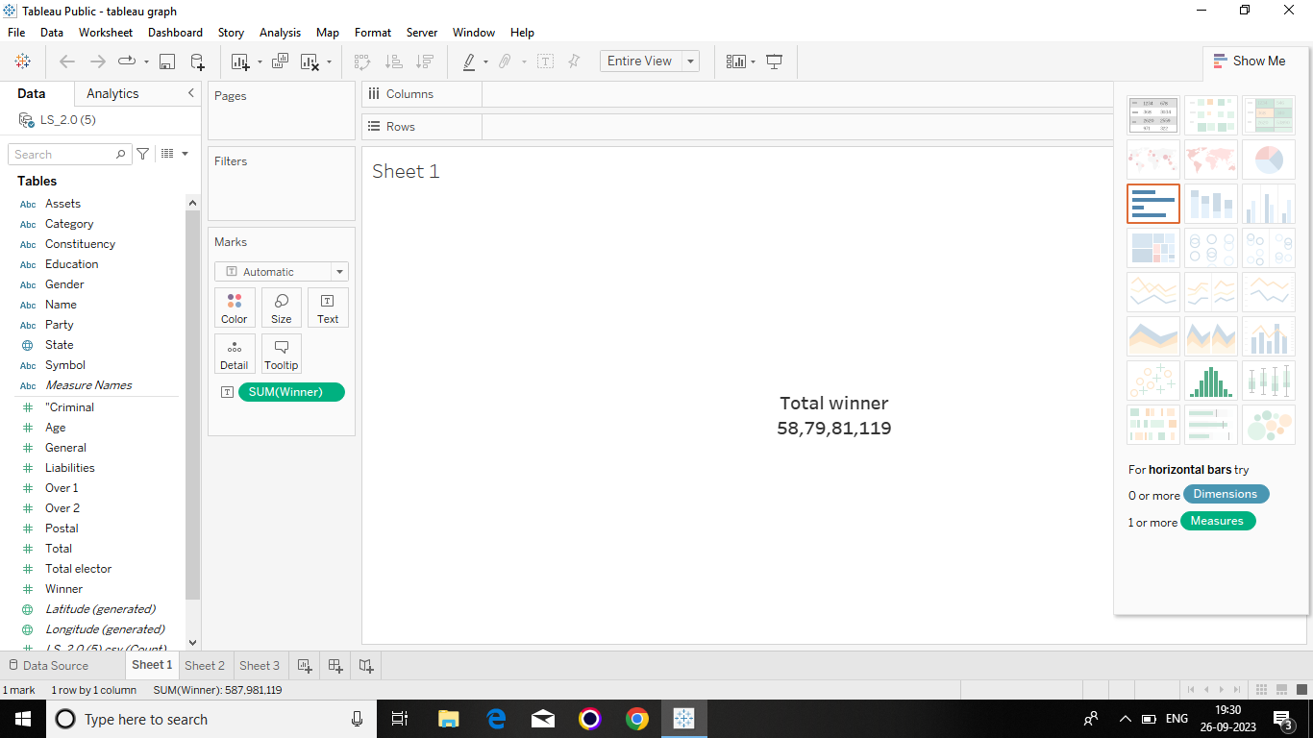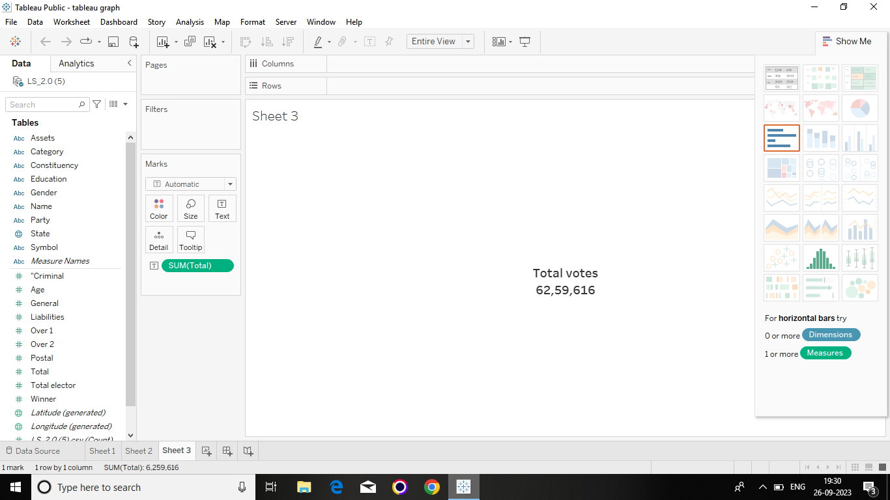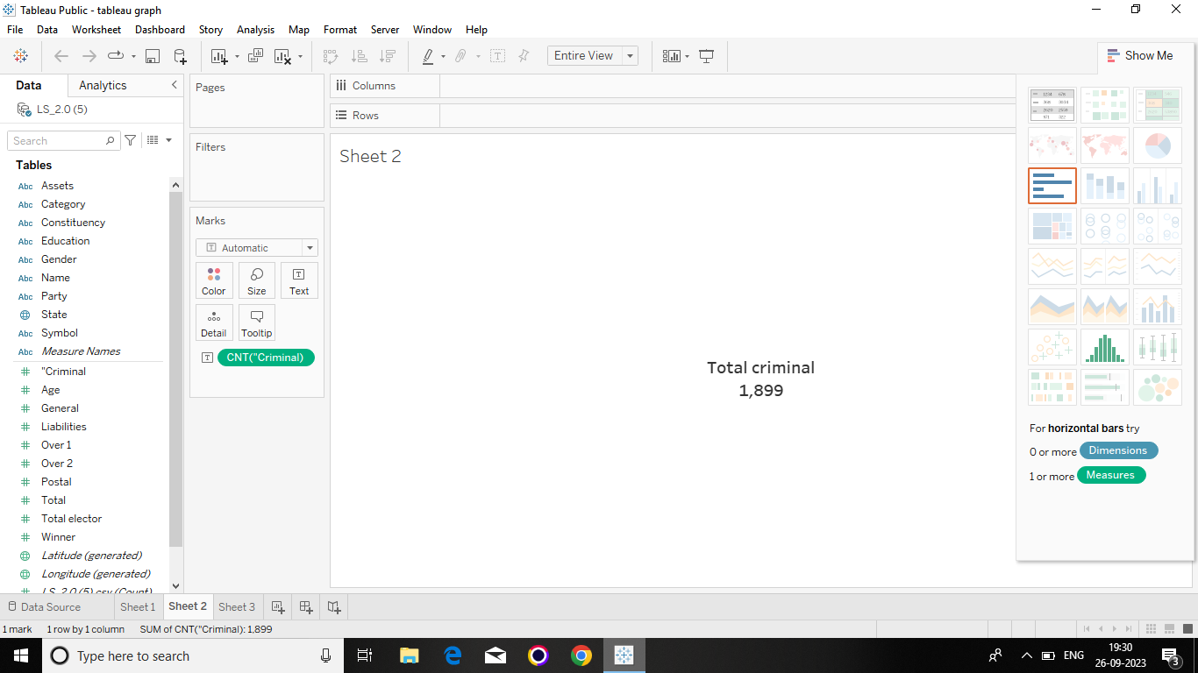

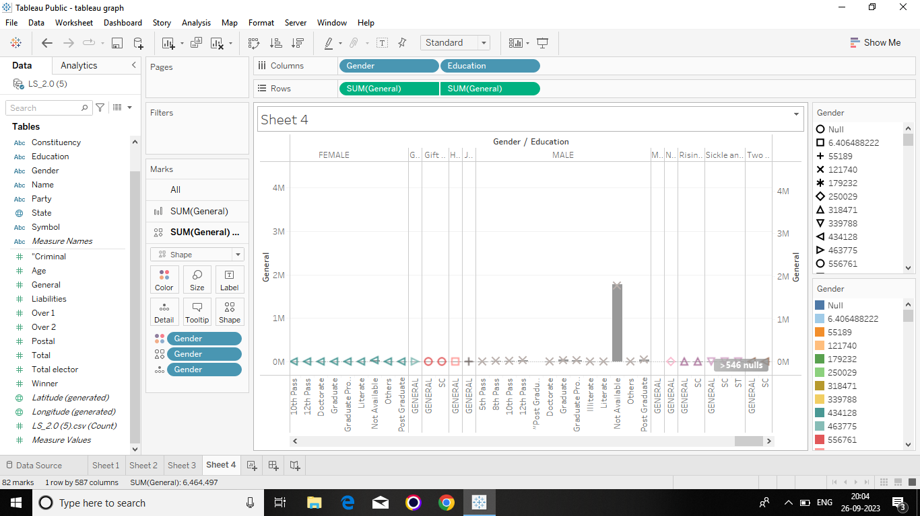

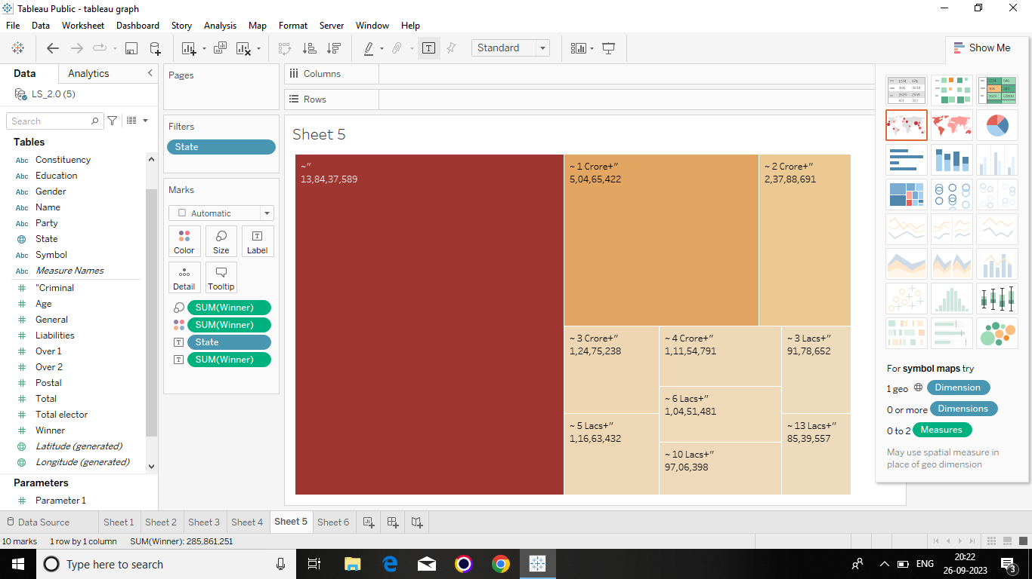

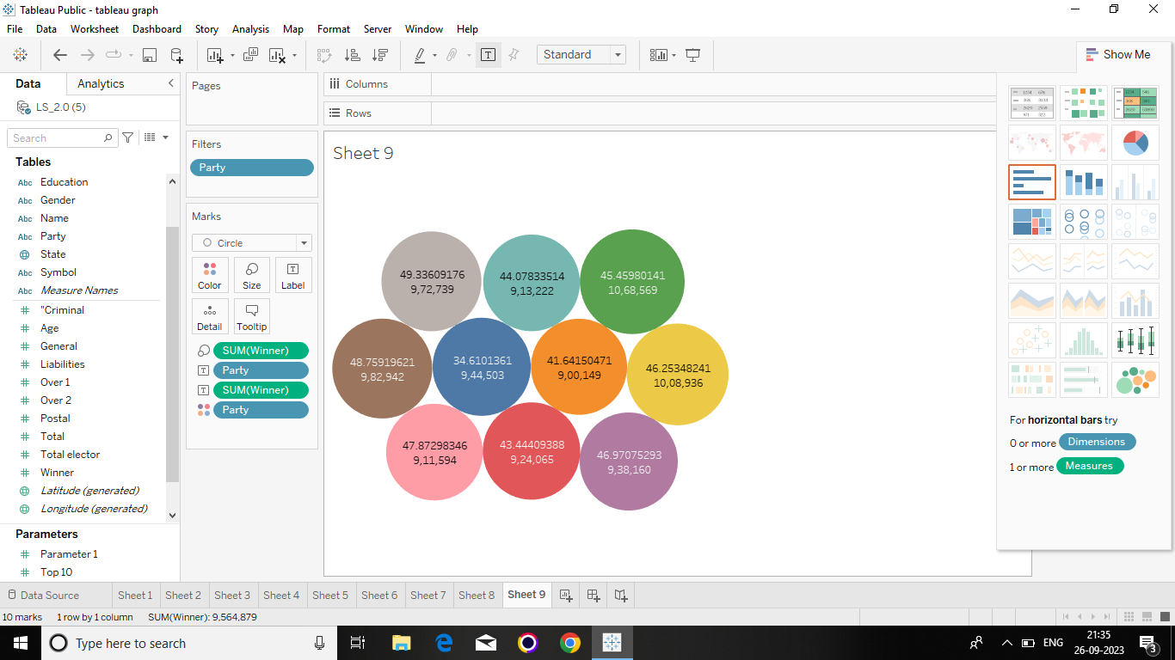

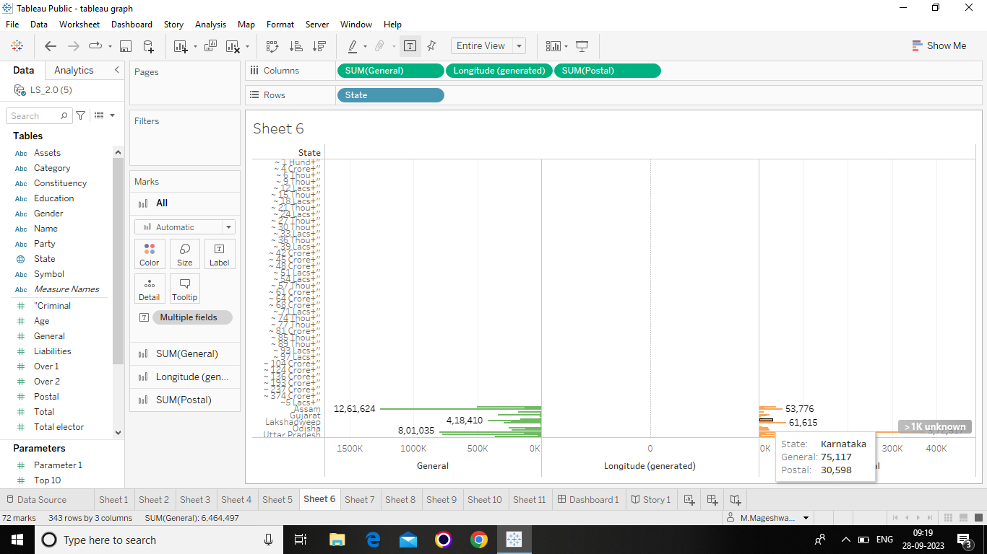

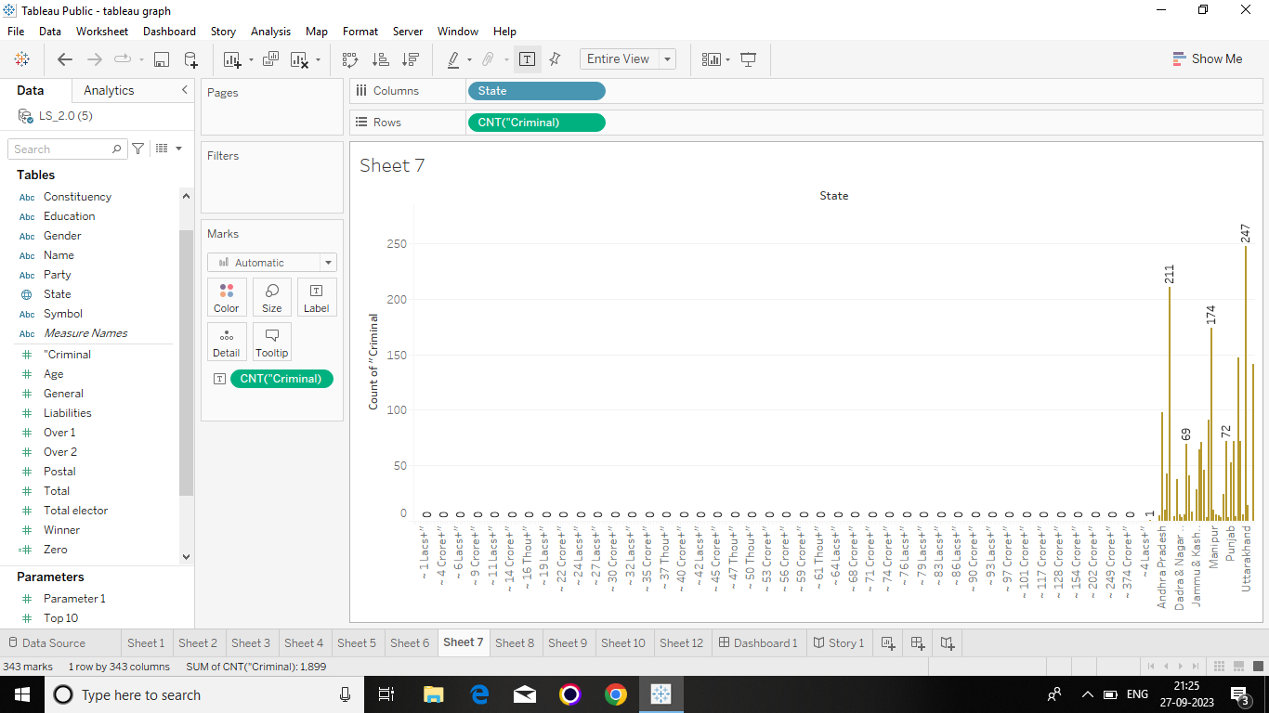

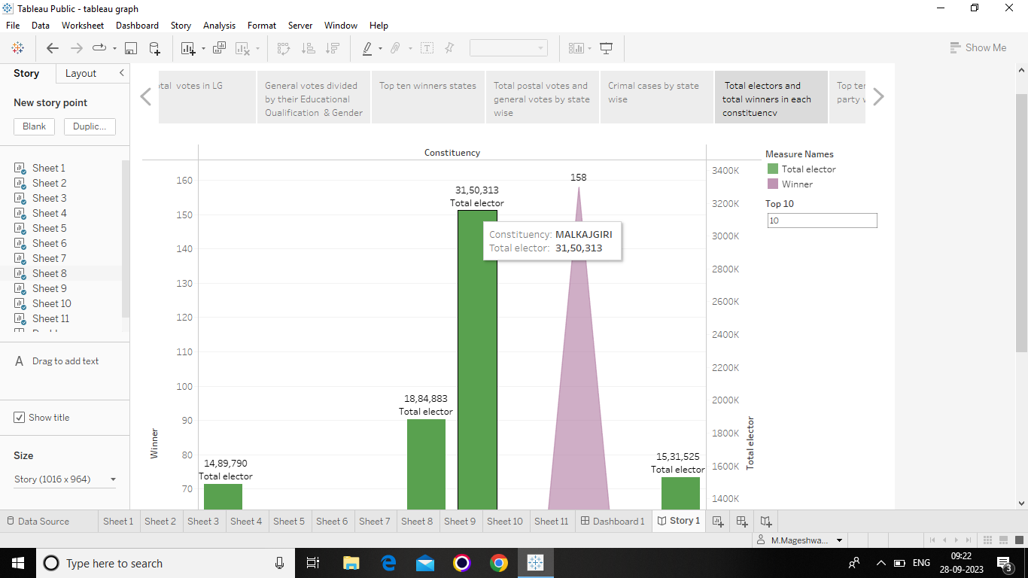

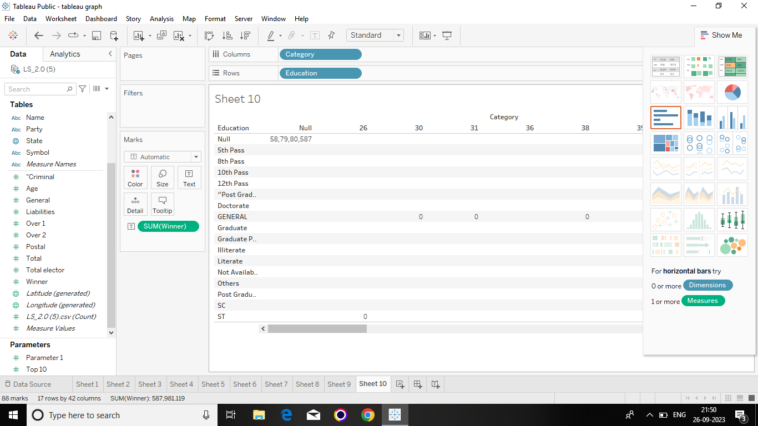

* Dashboard and story published in a Tableau puplic.

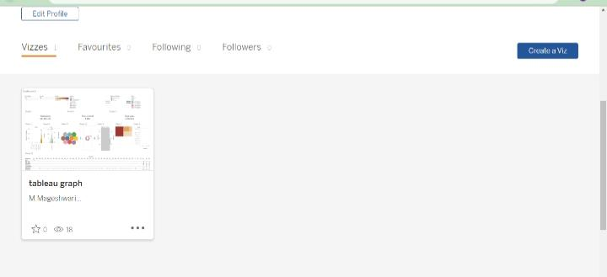

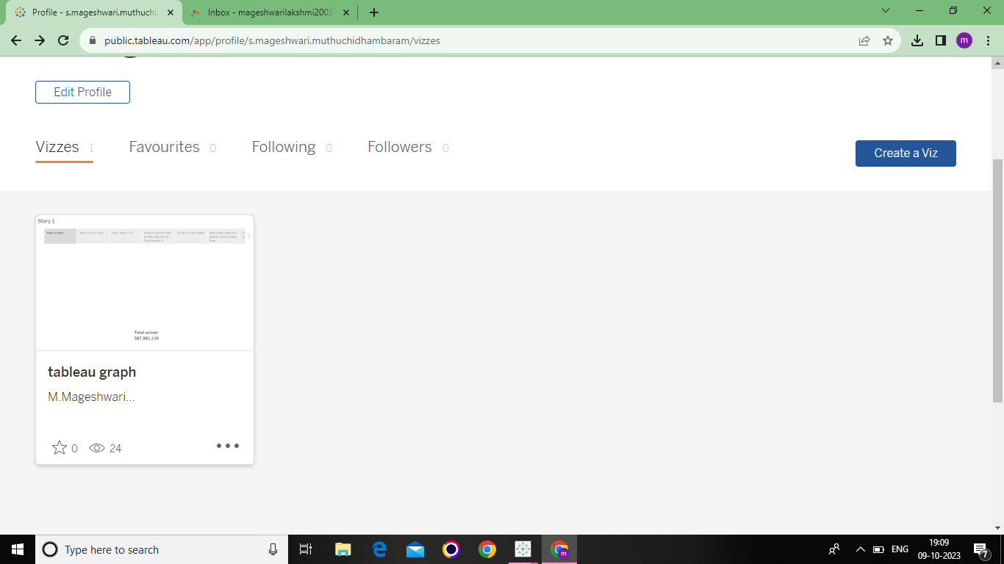

**Advantages and Disadvantages :**

* This project is very useful to us and understanding the data base analysis of constituency Lok sabha election in 2019.
* It is very useful to improve our Technical knowledge.
* Time duration is not enough and At the same time high amount of network needed for this project. So, it is a disadvantages.

**Conclusion :**

* Finally me and my team members are analysing for Political juggernauts: Constituency lok sabha elaction in 2019.
* We are learning how to create Empathy map, brainstorming, dashboard and story for the given data with the help of the following web. Such as, Mural. Co, Git hub and Tableau.

**Future scope:**

* This project is very useful for us.
* We all are learned about many websites. This websites very useful for our future.

.